|  |
| --- |
| FIXCODE |
| Programming Mistakes |
| Fiza Batool  153159  BSCS-V |

Programming Mistakes

# Mistake #1 :

|  |
| --- |
| 1:Undeclared Variables: |
|  |  |
|  | int main() |
|  | { |
|  | cin>>x; |
|  | cout<<x; |
|  | } |
|  |  |
|  |  |

# Correction:

**Question :** Huh? Why do I get an error?

**Answer:** A variable can’t be utilized until it is initialized.

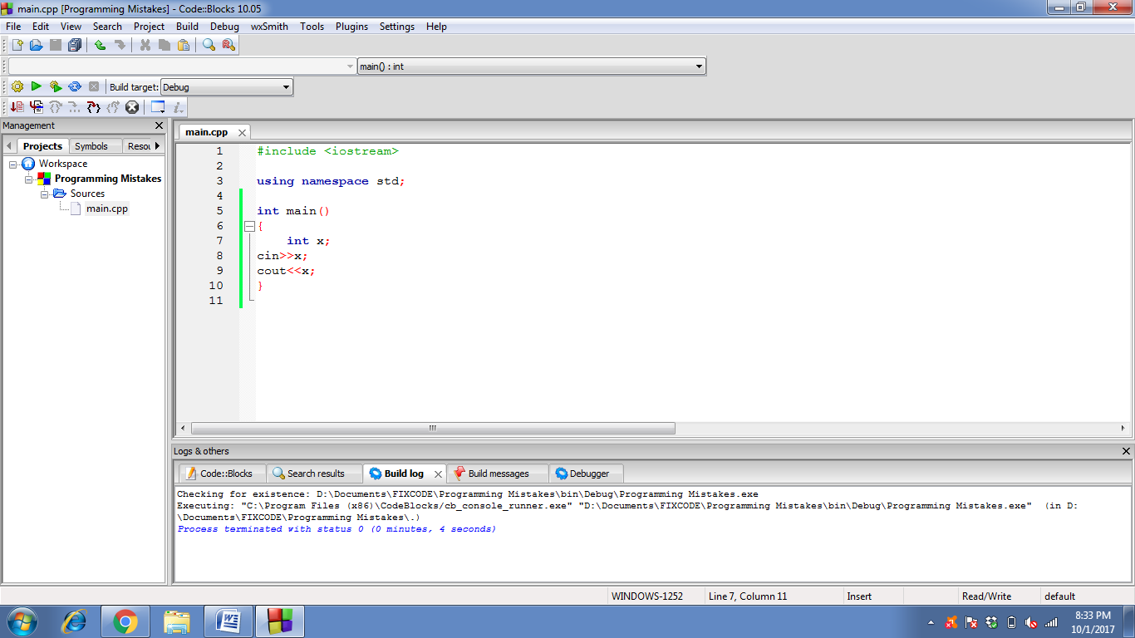

# Mistake #2 :

|  |
| --- |
|  |
| 2:Uninitialized variables: |
|  |  |
|  | int count; |
|  | while(count<100) |
|  | { |
|  | cout<<count; |
|  | }  **Question:** Why doesn't my program enter the while loop?  **Answer:** The program is not entering in the loop because ‘count’ neither has any value nor the value of ‘count’ is increasing any way. |
|  |  |
|  |  |
|  |  |

# Correction:

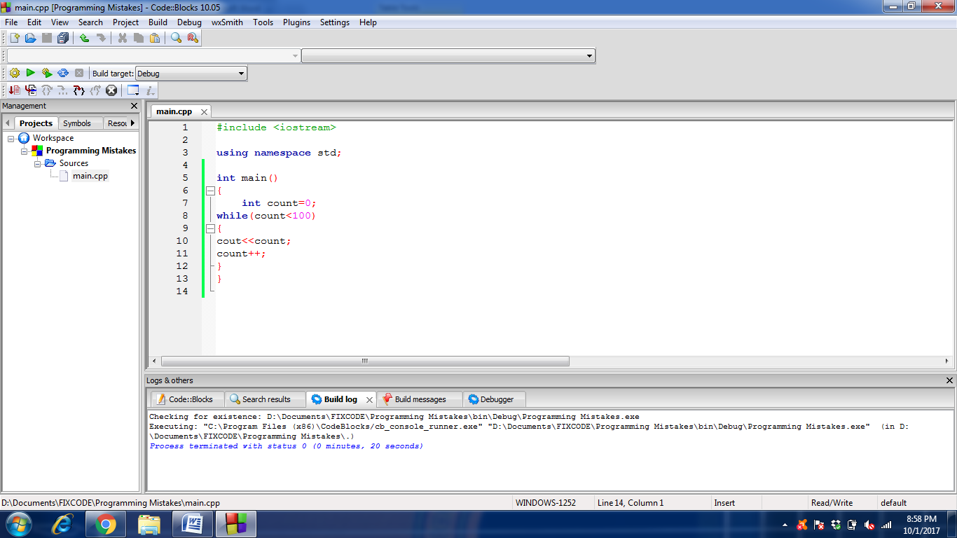

# Mistake # 3 :

|  |
| --- |
| 3: Setting a variable to an uninitialized value: |
|  |  |
|  | int a, b; |
|  | int sum=a+b; |
|  | cout<<"Enter two numbers to add: ";  **Question:** What's wrong with my program?  **Answer:** Very first problem is that variable isn’t initialized and its formula is defined where it should have been initialized. **=>**Another problem is that it is not getting any value of ‘a’ from the user. **=>**One more important point to note is that a formula for the input values is defined only when the inputs have been entered. |
|  | cin>>b; |
|  | cout<<"The sum is: "<<sum; |
|  | **=>When Run:** |
|  | Enter two numbers to add: 1 3 |
|  | The sum is: -1393 |

# Correction:

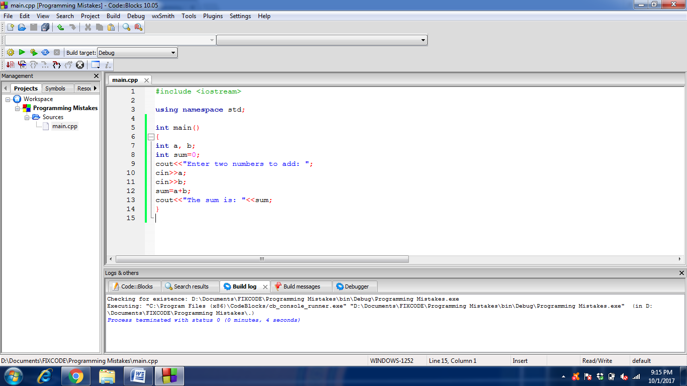

# Mistake #4:

|  |
| --- |
| 4: Using a single equal sign to check equality: |
|  |  |
|  | char x='Y'; |
|  | while(x='Y') |
|  | { |
|  | //... |
|  | cout<<"Continue? (Y/N)"; |
|  | cin>>x; |
|  | } |
|  |  |

# Correction :

**Question:** Why doesn't my loop ever end?

**Answer:** The loop here never ends because ‘=’ operation is used for initializing purpose whereas to check equality ‘==’ operation is used.

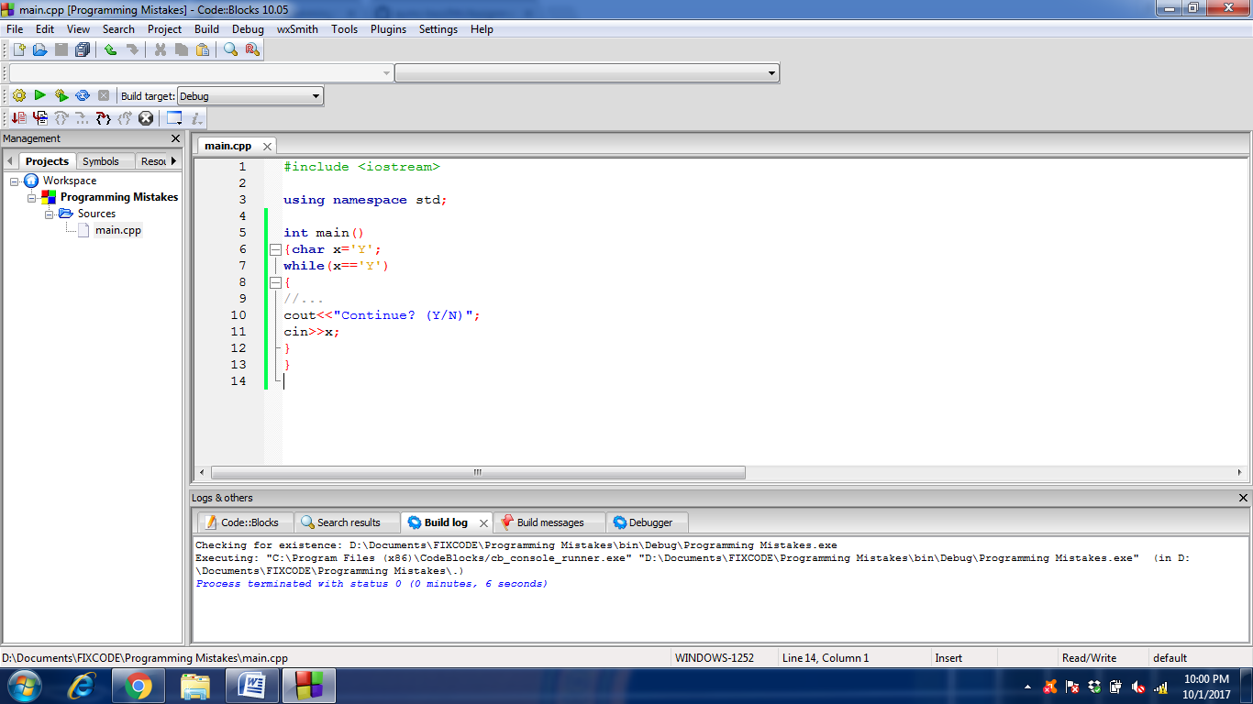

# Mistake #5:

|  |
| --- |
|  |
| 5:Undeclared Functions: |
|  |  |
|  | int main() |
|  | { |
|  | menu(); |
|  | } |
|  | void menu() |
|  | { |
|  | //...  **Question:** Why do I get an error about menu being unknown?  **Answer:** When using a function , its prototype is necessarily given before being called in ‘int main()’ or the function is defined before the function where its being called or else the compiler would not recognize the function . |
|  | } |
|  |  |

# Correction:

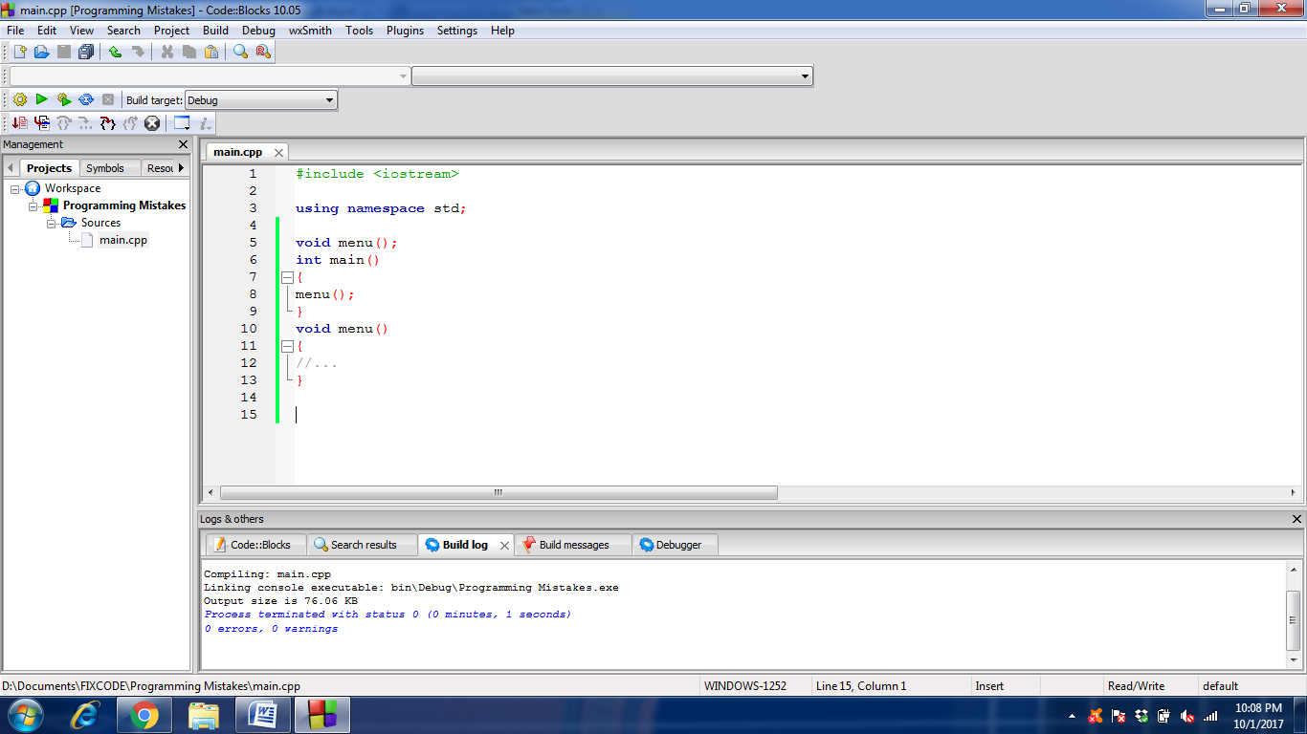

# Mistake #6:

|  |
| --- |
|  |
| 6: Extra Semicolons: |
|  |  |
|  | for(int x=0; x<100; x++); |
|  | cout<<x; |
|  |  |

**Question:** Why does it output 100?

**Answer:** Here is a syntax error that ‘;’ is not given after ‘for loop’ definition.

# Correction:

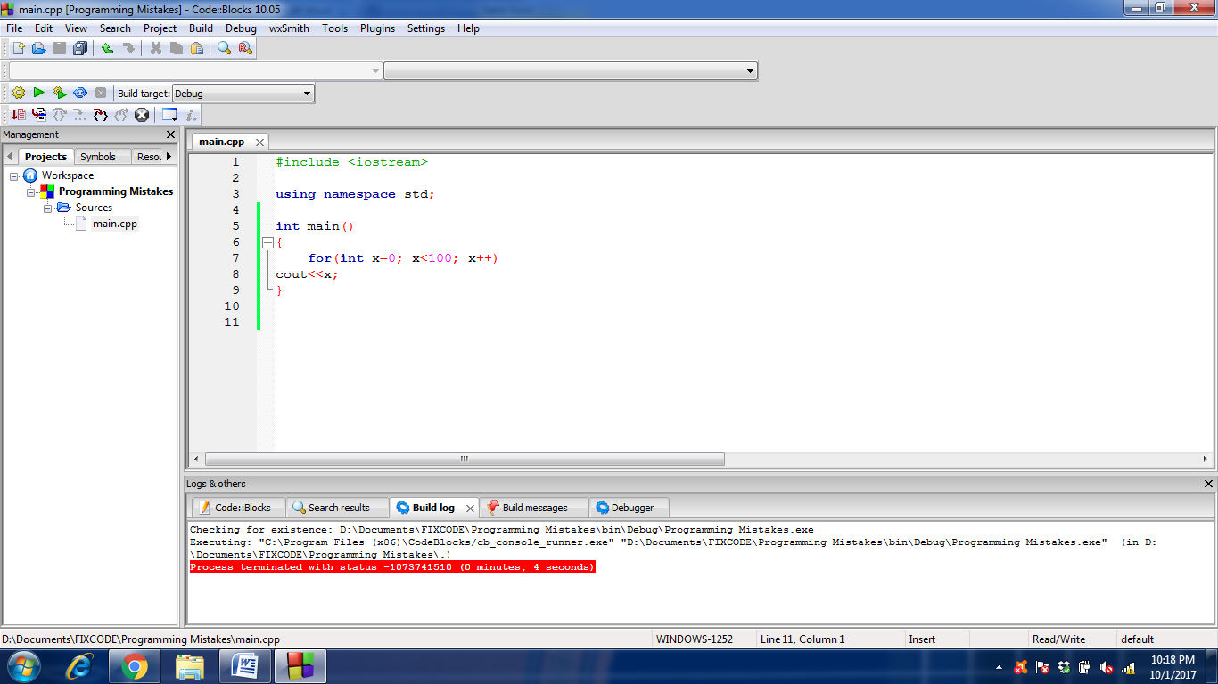

# Mistake #7:

|  |
| --- |
| 7: Overstepping array boundaries: |
|  |  |
|  | int array[10]; |
|  | //... |
|  | for(int x=1; x<=10; x++)  **Question:** Why doesn't it output the correct values?  **Answer:** When an array is initialized by some value ‘n’ it means its index will start from which means last index will be ‘n-1’ that shows that here in code we are exceeding the array boundary. |
|  | cout<<array[x]; |

# Correction:

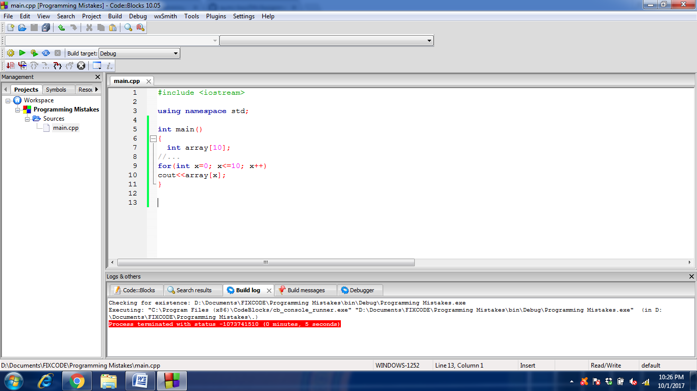

# Mistake #8:

|  |
| --- |
| 8: Integer division  **Question:** This code sets half to 0 not 0.5! Why? Because 1 and 2 are integer constants.  **Answer:** That is so because of wrong values , when ‘1’ and ‘2’ have no decimal values so the answer will also have no decimal values. |
|  |  |
|  | For example: |
|  | double half = 1/2; |

# Correction:

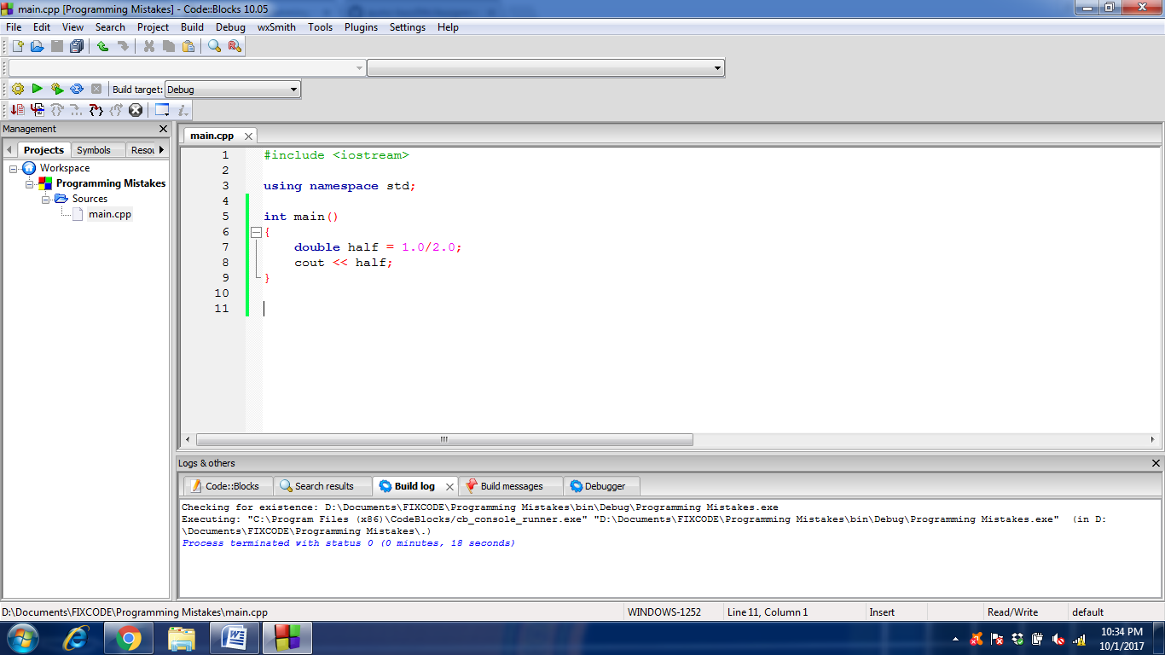

# Mistake #9:

9: Variable Name Styles

|  |
| --- |
|  |
| #include <stdio.h> |
|  | #include <string.h> |
|  |  |
|  | main() |
|  | { |
|  | char CatName[20] = "fluffy"; |
|  | char dogName[20] = "fido"; |
|  | char rat_Name[20] = "fester"; |
|  | int Catage = 3; |
|  | int dogs_age = 4; |
|  | int ratage = 1; |
|  | char myPet[20];  **Question:** Take a look at the below program. Can you see anything wrong? Besides the obviously bizarre choice of having a pet rat, do you notice anything?  **Answer:** NO, I cannot see other option. |
|  | int itsAge; |
|  |  |
|  | strcpy(myPet,rat_Name); |
|  | itsAge = ratage; |
|  | printf("My pet is %s\n",myPet); |
|  | } |
|  |  |

# Correction:

The code is okay. No correction needed.

# Mistake #10:

|  |
| --- |
|  |
| 10: Misusing the && and || operators: |
|  |  |
|  | int value; |
|  | do |
|  | { |
|  | //... |
|  | value=10; |
|  | }while(!(value==10) || !(value==20)) |
|  | **Question:** Huh? Even though value is 10 the program loops. Why?  **Answer:** There is wrong operator used , instead of ‘||’ , ‘&&’ will give much better results. **=>**this code also has a minor syntax error , ‘;’ is missing after while loop. |

# Correction:

